# **Airflow Automation Task**

# Your mission is to build a basic workflow using [Apache](https://airflow.apache.org/docs/apache-airflow/1.10.9/index.html) Airflow.

**What is Airflow?**

<https://airflow.apache.org/docs/apache-airflow/2.5.1/index.html>

The workflow (DAG) needs to create a file according to a user parameter and print it to the console

### **Requirements**:

* Input -
  + The workflow should be triggered by REST API POST request with an environment type parameter provided in the body request  
    <https://airflow.apache.org/docs/apache-airflow/stable/stable-rest-api-ref.html>
  + “environment_type” parameter is mandatory, with the following allowed values:
    - *development*
    - *production*

For any different input value, the workflow should fail

* Output -
  + In case of *environment_type* = *‘development*` -
    - printing "hello ciValue from development branch" into a local file named "civalue_development _<timestamp>.txt"
  + In case of *environment_type* = `*production’* -
    - printing "hello ciValue from production branch" into a local file named "civalue_production_<timestamp>.txt"
  + The content of the written file should be printed to console
  + Response for POST request - default apache workflow response

**Example of POST request using curl:**

> curl -X POST 'http://localhost:8080/api/v1/dags/<dag_id>/dagRuns' \

-H 'Content-Type: application/json' \

--user "airflow:airflow" \

-d '{

"conf":{"environment_type": "development"}

}'

**Example of POST request using POSTMAN:**

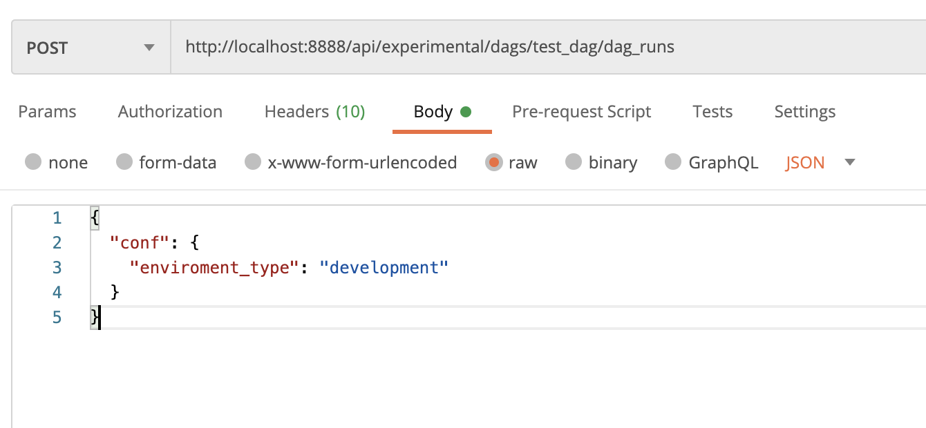

**Example of successful response:**

{"execution_date":"2020-11-11T18:45:05+00:00","message":"Created <DagRun test_dag @ 2020-11-11 18:45:05+00:00: manual__2020-11-11T18:45:05+00:00, externally triggered: True>"}

### **Workflow steps**:

1. enviroment_branch - Parses the environment type parameter given by the user and chooses the correct workflow branch to execute
2. file_creation -
   1. file_creation_development - printing "hello ciValue from development branch" into a local file named "civalue_development _<timestamp>.txt"
   2. file_creation_production - printing "hello ciValue from production branch" into a local file named "civalue_production_<timestamp>.txt"
3. print_to_console - Reads the newly created file and prints its content to the console

Example of how the workflow looks like:

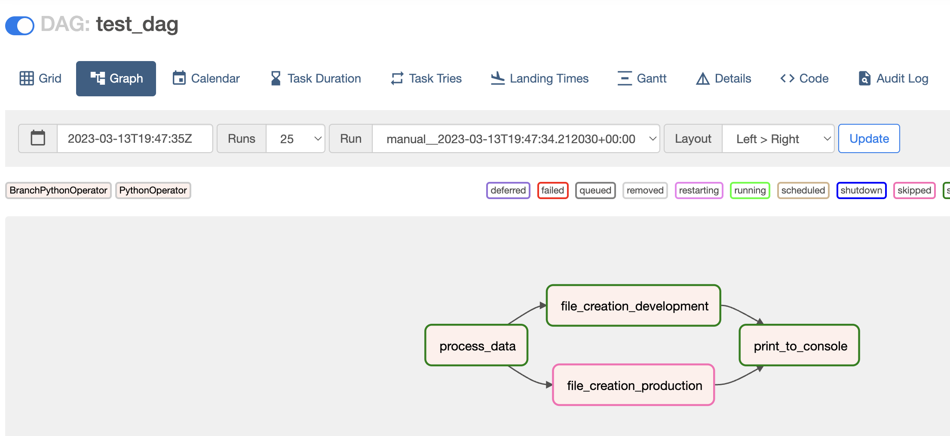

**Notes**:

1. The environment setup is based on Airflow 2.5.1, so make sure you work with the right documentation
2. There are a lot of amazing Airflow operators, but in this task you are only allowed to use “PythonOperator” and “BranchPythonOperator”

**Environment setup guide**:

1. Install Python 3.7 - <https://www.python.org/downloads/release/python-370/>
2. Python IDE of your choice (PyCharm is recommended https://www.jetbrains.com/pycharm/download/)
3. Install Docker Engine - <https://docs.docker.com/desktop/>
4. Install REST API tool of your choice (POSTMAN is recommended https://www.postman.com/downloads)
5. Follow this guide to initialize a local airflow instance: <https://airflow.apache.org/docs/apache-airflow/stable/howto/docker-compose/index.html#running-airflow-in-docker>
6. Disable example dags, by editing the docker-compose.yaml file, or in any other way.
7. Go to <http://localhost:8080/>. You should be able to access the Airflow web application.

The setup installation should take up to 1 hour and is **not** part of the test. If you have any issues setting up the environment please contact us.

**References**:

1. Apache Airflow - <https://airflow.apache.org/docs/apache-airflow/2.5.1/tutorial/index.html>
2. Docker logs for basic debugging - https://docs.docker.com/config/containers/logging/